UWB DSTO (Distributed) Module
Principle: The TOF (Time of Flight) algorithm measures the propagation time Δt of a signal from the transmitter to the receiver (unidirectional or bidirectional), and multiplies it by the speed of light c to obtain the distance d.
Formula: d = c × Δt
DSTO uses Two-Way Ranging (TWR): The transmitter sends a request, the receiver replies, the transmitter calculates the round-trip time, subtracts the processing delay, and then divides by two.
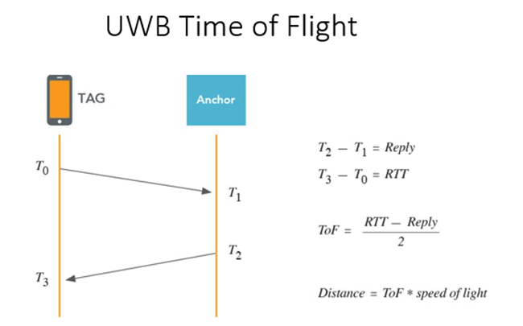

1. What are the advantages of the DSTO module?
Existing modules (referencing "Zhibo Module Hardware Manual v1.1.1") are mainly used for "fixed area positioning," whereas the DSTO module mainly solves the problem of "dynamic mutual ranging." Its core function is mutual ranging. The comparison is as follows:
Comparison Dimension | MaUWB Module | DSTO Distributed Module
Ranging Logic | Tags can only measure the distance to a fixed base station (anchor). Tags cannot communicate with each other. | Within the effective communication range (approx. 200m open/visible), every device can acquire the distance of all other devices in real-time.
Refresh Rate | Max 100Hz | Max 500Hz
Deployment Difficulty | High: Requires setting up 2 base stations in advance, calibrating coordinates, and connecting to a computer for calculation. | Low: No central node required. Devices automatically form a network when powered on; plug-and-play.
System Capacity | 8 Base Stations + 64 Tags | Theoretically unlimited IDs (Note: Limit of approx. 20 devices in the same area/100m radius to avoid data loss)

2. What is it used for?
It is used for "High-frequency interaction" and "Safety/Anti-collision":

Drone/Robot Formation: Utilizing the 500Hz high refresh rate to allow multiple drones or robots to maintain a fixed formation while flying/moving, sensing neighbor positions in real-time to avoid collisions.

Safety Anti-collision Warning: Suitable for factory scenarios like "Forklift vs. Forklift" or "Car vs. Personnel" anti-collision. It triggers an alarm or action immediately when the distance between two objects is less than a set value.

Smart Following & Social: Such as smart luggage following owners, or exhibition badges recording "who chatted with whom" (based on proximity judgment).

3. How to use it?

Hardware Connection: Uses standard UART serial communication. It can be directly plugged into existing ESP32 development boards for use.

Software Logic:
Settings: Use commands to assign a unique ID to each module.
Get Data: The DSTO module outputs a list directly via serial port: "ID:2 (Distance 2.0m), ID:3 (Distance 1.5m)..."

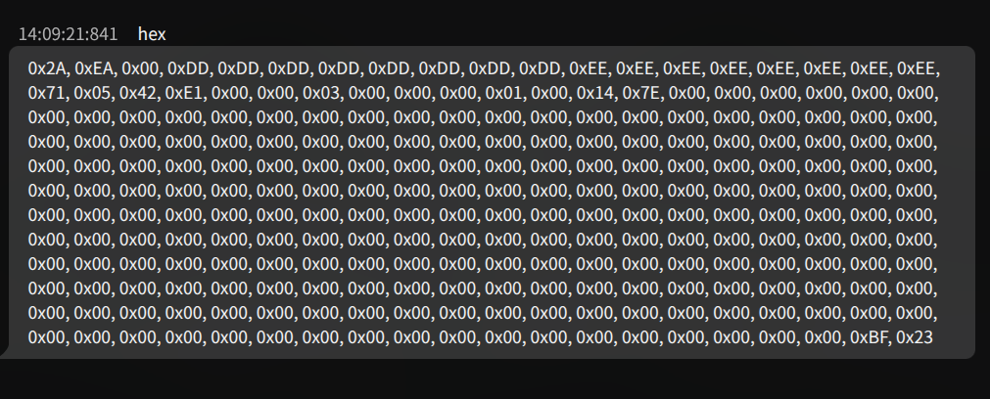
According to the communication protocol provided by Jiuling, please refer to it for more details http://img.jiulingdianzi.com/2025-10-31/b9731761904343.pdf
Field | Type | Length (Byte) | Description
head | uint8_t | 1 | Packet Header (Fixed: 0x2A)
cmd_len | uint16_t | 2 | Data frame length (Length of fields: cmd_saddr to reserve)
cmd_saddr | uint64_t | 8 | Self long address (Reserved 8 bytes)
cmd_daddr | uint64_t | 8 | Target long address (Reserved 8 bytes)
cmd_type | uint8_t | 1 | Command frame type (0x02: Node config, 0x10: OTA upgrade, 0x71: Distributed ranging)
cmd_direct | uint8_t | 1 | Command frame direction (1: Engine req, 2: Dev resp, 3: Dev req, 4: Engine resp, 5: Engine report, 6: Dev report)
dev_time | uint32_t | 4 | Device communication time
dev_devID | uint32_t | 4 | Unique ID of the device
dev_role | uint16_t | 2 | Device Role
dev_capacity | uint8_t | 1 | Device Capacity
dev_sn | uint32_t | 4 | Device reporting sequence number (SN)
dev_onlineCnt | uint8_t | 1 | Number of devices online in real-time
other(1) para | uint64_t | 8 | Basic info of other device (1) [Note 1: Bit structure]
other(1) dist | uint16_t | 2 | Distance parameter of other device (1) (Unit: cm)
... | ... | ... | (Repeated for devices 2 to 19)
other(20) para | uint64_t | 8 | Basic info of other device (20) [Note 1: Bit structure]
other(20) dist | uint16_t | 2 | Distance parameter of other device (20) (Unit: cm)
check | uint8_t | 1 | Checksum bit (Checksum of fields from cmd_saddr to before check)
foot | uint8_t | 1 | Packet Footer (Fixed: 0x23)

